This document will help you to understand the steps to connect VAPPCONNECT remotely. There are various ways to connect to Exxon-mobile network to connect V-App via SYNCRUDE VPN gateway.

**Contents**



**vAppConnect**

Remote Access User Guide

System Requirements/Important Information 2

Connecting to vAppConnect using a Software Token 3

Downloading and Installing Citrix Workspace app 4

Launching Applications from vAppConnect 6

Security and Help 7

Getting started

**System Requirements/Important Information**

## Cisco SSL VPN Clientless System Requirements

Clientless SSL connections does not require any software to be installed on device. Below are the minimum requirements to connect to clientless SSL VPN.

* Client system with latest operating system and latest security patches installed.
* Latest web browsers (example google chrome, Mozilla Firefox and so on) should be installed with Active X enabled.
* Java (Sun JRE) should be installed with latest update.
* The computer must have access to the Internet through an Internet Service Provider (ISP), a company network, or a cellular (3G/4G) service.
* The firewall between your computer and the Internet needs to allow SSL VPN traffic to the Internet. If you have trouble connecting with these instructions, your firewall administrator needs to know that the VPN connection uses TCP 443 (SSL/ HTTPS) and UDP 443 (DTLS) and require that the rules allow outbound connection (i.e. from your network to ExxonMobil VPN gateways).

If you are using a Proxy Server on your Internet browser, do make sure the Citrix connection ports, TCP 1494 and UDP 1604, are allowed through your Proxy Server (Extending the SSL Tunnel Port Range).

The Syncrude Clientless vpn vApp access, please type this URL in your web browser [**https://diamond.syncrude.com/vappconnect**](https://diamond.syncrude.com/vappconnect)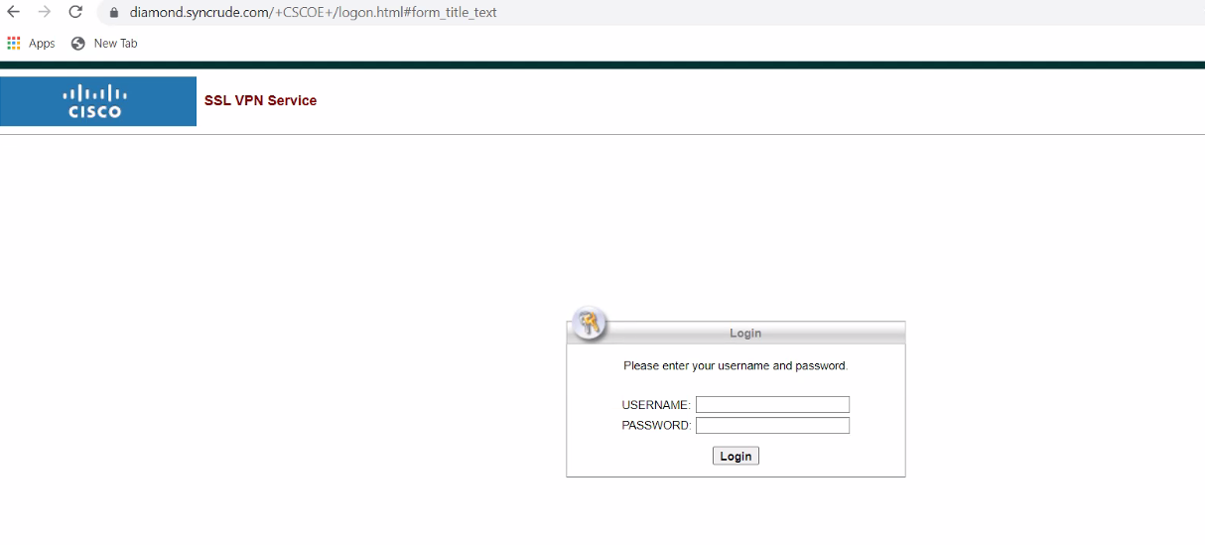

**Connecting to vAppConnect using a SecureAuth Software Token**

Type Authorize username and password is provided by your team.

Using link for Secure Auth guide.

<file:///C:/Users/farsyed/AppData/Local/Microsoft/Windows/INetCache/Content.Outlook/KEPTDKT5/SecureAuth%20Software%20Token%20-%20Enrollment%20guide.pdf>

**How to Download and Install Citrix Workspace App**

How to download and install CitrixWorkspace:

**1. How to download and install Citrix Workspace**

You need to be running Citrix Workspace app version 1810 saved it. Double click **CitrixWorkspaceApp**. or above.

5. Open Windows Explorer and find **CitrixWorkspaceApp** where you

the file to your hard drive into a temporary directory or your



3.

Select

**Workspace app**

for [preferred system] and

click the latest version of

Citrix Workspace app.

4.

Click the Download Citrix Workspace app button to download

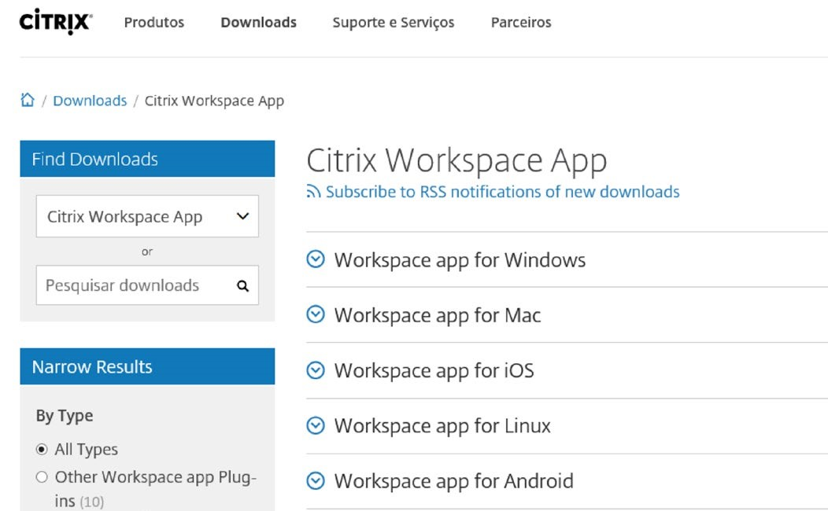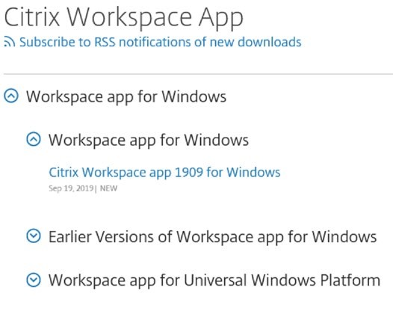

[1](https://www.citrix.com/downloads/workspace-app/)

[.](https://www.citrix.com/downloads/workspace-app/)

[Click her](https://www.citrix.com/downloads/workspace-app/)

[e](https://www.citrix.com/downloads/workspace-app/)

[t](https://www.citrix.com/downloads/workspace-app/)

o open the Citrix Workspace

web

site.

2

.Select your

preferred Workspace app

and click on

the

icon to open it.

desktop.

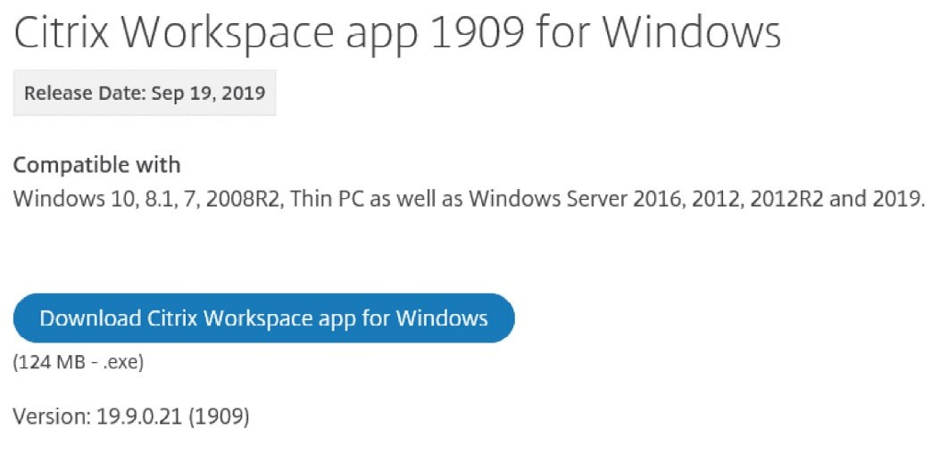

6.

A Prompt will appear

during the installation of

**Start**

for installation.

Check

7.

8.

Another prompt

will appear after the

installation completes.

Click

**Finish**

to finish.

**I accept license**

**agreement**

and

then

click

**Install**

.

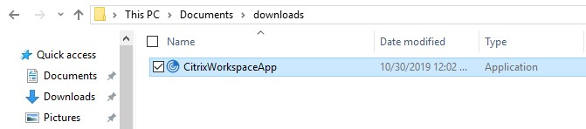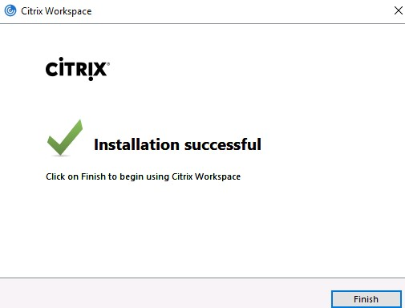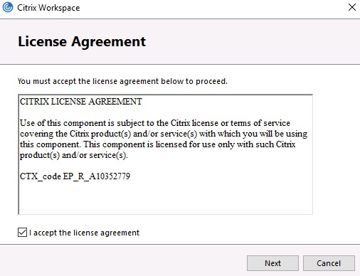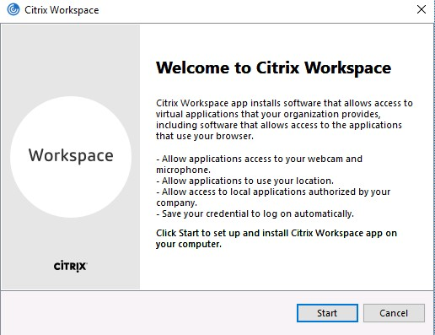

Citrix

Workspace

. Click

**How to Download and Install Citrix Workspace App**

## 2. Citrix Login

1. After you successfully connect to vAppConnect using your software token or hardware token, you will see the homepage.

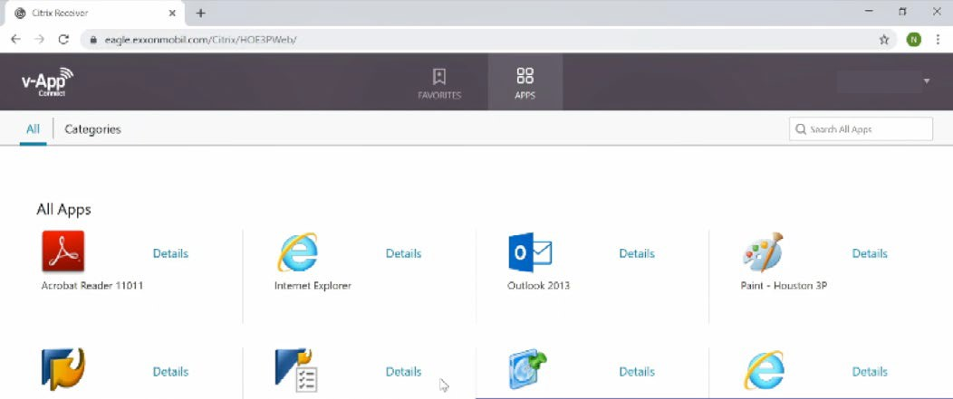

1. Select the application or desktop you want to access. The Citrix client will activate in a separate Citrix Client window.

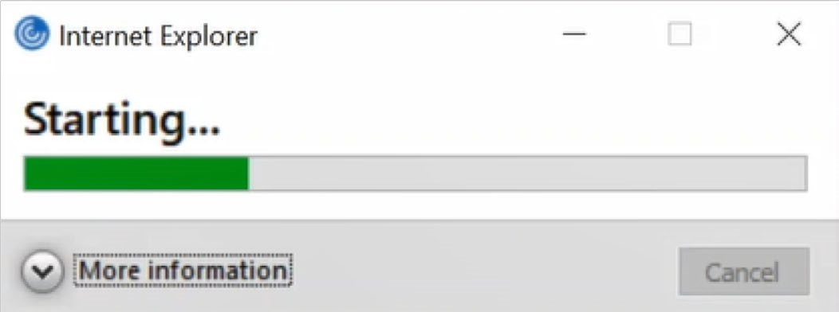

1. The first time you use vAppConnect, you will receive a few pop-ups. Check **Do not ask me again for this site** and click **Permit use** and then **Permit all access**.

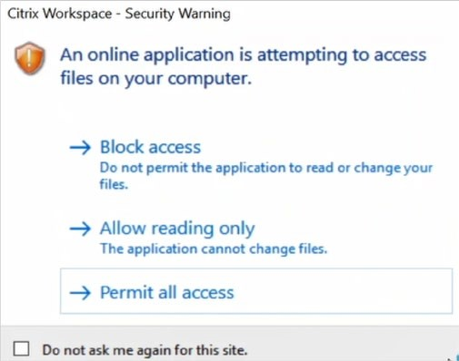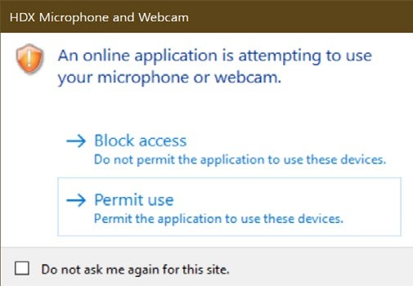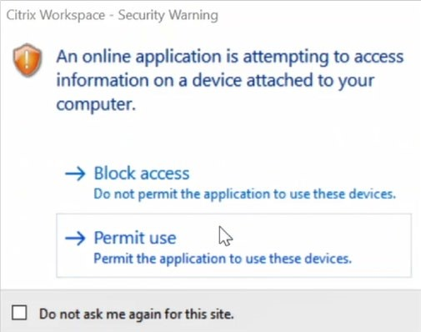

Another pop

-

up may

appear when you launch

Skype

.

->

If you are using Chrome or Edge, you will see another pop-up. Click **Open** to launch your application



1. Start using your application!

# Launching applications from

How to launch applications from vAppConnect:

**Launching applications from vAppConnect**

## Main Tab

This tab is your **APPS** tab where all your applications are displayed. Click on an application to launch.

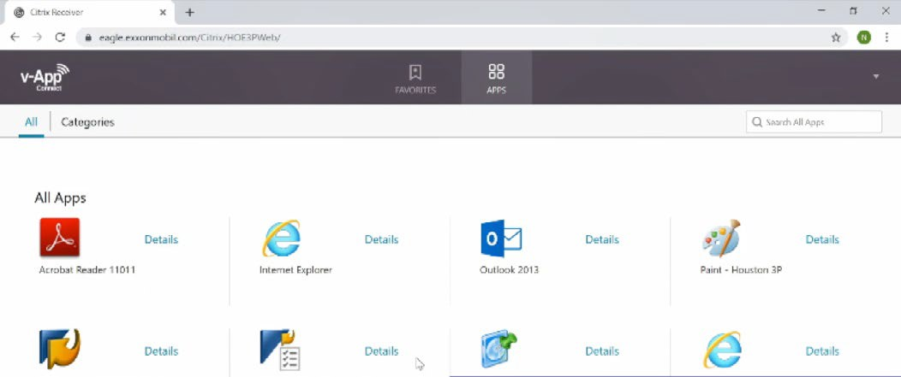

## Other Tabs

This tab is your **FAVORITES** tab where all of your favorited applications will show up.

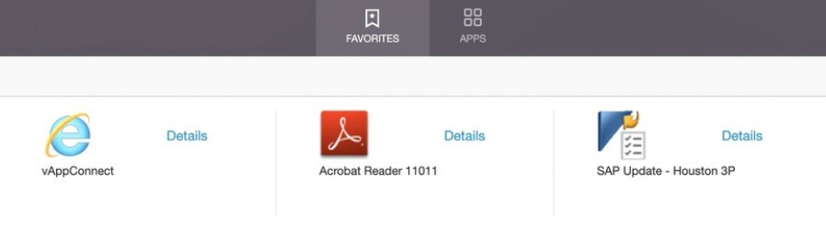

If enabled, you will see a **DESKTOPS** tab with the LandingDesktop application. This application allows you to access a virtual desktop.

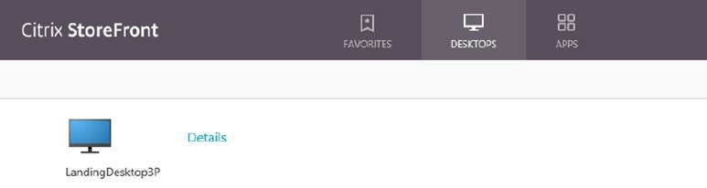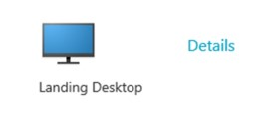

## Logging off the Syncrude network

1. Right-click the **Citrix Workspace App icon**, located in your system tray.

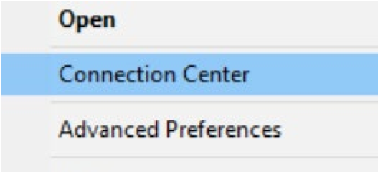

1. Select **Connection Center**
2. Select the **Server**, click **Log Off**

To launch the desktop, click the application.



**Note:**



**Note:**

The app

lication

name may vary based on your user account.

If your computer is idle for

16

hours, you will be

automatically logged out from your app

lications

and your

session

. You

will need to relaunch vAppConnect.

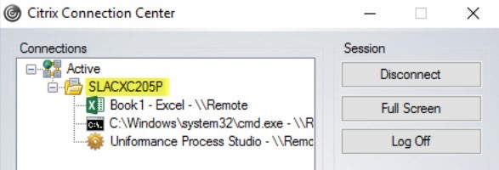

## Security

**Security**

### Importance of network security

Each Syncrude business partner is responsible for the proper handling and security of Syncrude information and systems. A number of precautions are appropriate when accessing to the Syncrude network. Some of these are discussed in the following sections.

### Computer risks and precautions

* Use a screen saver with password protection enabled on computers loaded with remote access software. The screen saver inactivity timeout should be set to 15 minutes or less.
* If possible, do not share computers among different users which have been configured for remote access to the Syncurde network and loaded with the remote access software.
* Log off when finished.

### Please convey to the helpdesk that this is related to “third party remote access service clientless access.”